SIMATS ENGINEERING
ASSESSMENT TOOL 3: Mock Interview

COURSE NAME: Cloud Computing and
Big Data Analytics

COURSE CODE: CSA15

COURSE OUTCOME COVERED
CO5: Design big data processing systems using the Hadoop ecosystem including HDFS, MapReduce, and YARN.
(BL5)
Assessment Tool Weightage: 10%
Dave&#39;s Taxonomy: Articulation (Level 4)
Question Count: 10

Total Marks: 25

Code of Conduct
I ARTHI REDDY(192565054)_ _ (Name / Reg No) certify that this submission is my original work and that I have adhered
to the guidelines specified for this assessment.
I understand that any violation of academic integrity rules will result in disciplinary action.
Signature of the student: ____________________
Assessment Tasks
Mock Interview
Answer the following interview-oriented questions clearly and concisely. Support your responses with architecture-
level reasoning wherever appropriate.
1. Explain the difference between HDFS and traditional file systems.
2. Why is replication important in distributed storage systems?
3. How does MapReduce divide work between map and reduce phases?
4. What role does YARN play in large-scale Hadoop processing?
5. Differentiate NAS and SAN in an enterprise data environment.
6. What is the purpose of ETL in a big data pipeline?
7. How does Apache NiFi help in data integration workflows?
8. What are the key failure points in a Hadoop cluster and how would you handle them?
9. How would you design a secure data ingestion pipeline for a large organization?
10. How would you explain a scalable Hadoop-based processing system to a non-technical manager?]
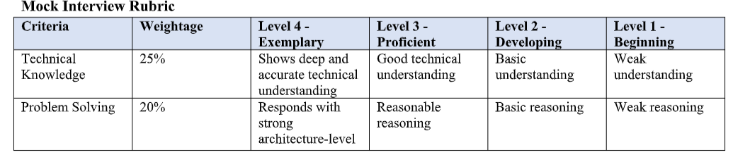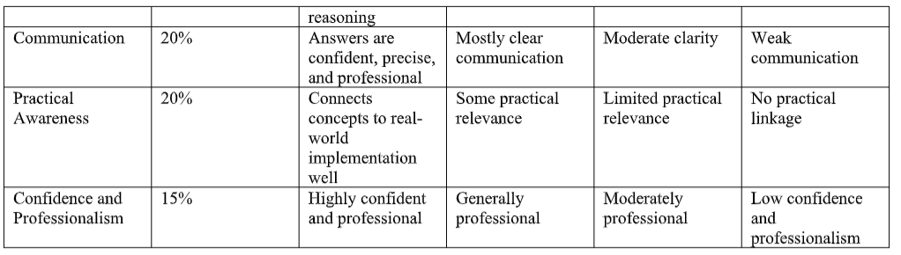

1. Difference Between HDFS and Traditional File Systems
Answer:
- HDFS (Hadoop Distributed File System) is designed to store very large files across multiple computers.
- Traditional file systems usually store data on a single computer or storage server.
- HDFS divides files into blocks and distributes them across multiple nodes.
- HDFS provides replication for fault tolerance.
- Traditional file systems generally have limited scalability compared to HDFS.

2. Importance of Replication in Distributed Storage
Answer:
- Replication means keeping multiple copies of the same data on different nodes.
- It protects data from hardware or node failures.
- If one node fails, another copy can be used.
- It improves data availability and reliability.
- HDFS commonly uses replication to provide fault tolerance.

3. MapReduce Map and Reduce Phases
Answer:
- Map phase: Input data is divided into smaller parts and processed by multiple mapper tasks.
- The mapper converts input into key-value pairs.
- Shuffle and Sort: Intermediate key-value pairs are grouped based on their keys.
- Reduce phase: Reducers process the grouped data and generate the final result.
- This allows large datasets to be processed in parallel.
Flow:
Input → Map → Shuffle & Sort → Reduce → Output

4. Role of YARN in Hadoop
Answer:
- YARN (Yet Another Resource Negotiator) manages resources in a Hadoop cluster.
- It allocates CPU, memory, and other resources to applications.
- It schedules and monitors different processing jobs.
- It allows multiple applications to run on the same Hadoop cluster.
- YARN improves resource utilization and scalability.

5. Difference Between NAS and SAN
Answer:
NAS | SAN
Network Attached Storage | Storage Area Network
Provides file-level storage | Provides block-level storage
Accessed using network protocols | Usually uses Fibre Channel or iSCSI
Easier to manage | More complex
Suitable for file sharing and backups | Suitable for databases and high-performance applications

6. Purpose of ETL in a Big Data Pipeline
Answer:
ETL stands for Extract, Transform, Load.
- Extract: Collect data from different sources.
- Transform: Clean, filter, format, and convert the data.
- Load: Store the processed data into a target system.
- ETL improves data quality and consistency.
- It prepares data for analysis and decision-making.

7. Apache NiFi in Data Integration
Answer:
- Apache NiFi is a tool used for automating data flow between different systems.
- It can collect data from databases, files, APIs, sensors, and other sources.
- It supports data routing, filtering, transformation, and delivery.
- NiFi provides a visual interface for designing data flows.
- It also supports monitoring, security, and error handling.

8. Key Failure Points in a Hadoop Cluster
Answer:
Major failure points include:
- DataNode failure – handle using HDFS replication.
- NameNode failure – use a High Availability setup with standby NameNode.
- Network failure – use reliable and redundant network connections.
- Disk failure – use multiple disks and replication.
- Resource failure – YARN can monitor and reallocate resources.
Regular monitoring, backups, replication, and fault-tolerant configurations help maintain the cluster.

9. Designing a Secure Data Ingestion Pipeline
Answer:
A secure pipeline can be designed using:
- Authentication to verify users and data sources.
- Encryption during data transfer and storage.
- Access control to allow only authorized users.
- Data validation and cleansing to prevent malicious or incorrect data.
- Monitoring and logging to detect suspicious activities.
- Backup and recovery mechanisms to protect against data loss.
Flow:
Data Sources → Secure Ingestion → Validation → Encryption → Storage → Processing

10. Explaining a Scalable Hadoop System to a Non-Technical Manager
Answer:
A Hadoop system can be explained as a large team of computers working together.
- Instead of one powerful computer processing all the data, Hadoop uses many computers.
- Large data is divided into smaller pieces and processed simultaneously.
- Copies of data are maintained so that data is not lost if a computer fails.
- More computers can be added when the amount of data increases.
- Therefore, Hadoop provides scalability, reliability, and cost-effective big data processing.

